SIMATS ENGINEERING
ASSESSMENT TOOL 1: Experiments
COURSE NAME: COMPUTER VISION COURSE CODE:ITA0510 Slot A

COURSE OUTCOME COVERED
CO3: Analyze and extract image features using detection and matching techniques for effective image representation and comparison. (BTL 4)
Assessment Tool Weightage: 40%

QUESTIONS:3 Total Marks 30 Duration :60 Minutes
Annexure A
Experiments

Code of Conduct:
I K.RUCHITHA(192472299) cer tify that this submission is my original work and that I have adhered to the guidelines specified for this assessment.
I understand that any violation of academic integrity rules will result in disciplinary action.
Signature of the student :K.RUCHITHA
Rubrics for Evaluation
Criteria | Weightage (%) | Level 4 (Exemplary) | Level 3 (Proficient) | Level 2 (Developing) | Level 1 (Beginning) | Marks(100)
Understanding of Concepts | 25 | Demonstrates thorough understanding and effectively integrates multiple concepts/technologies | Good understanding with proper integration of most concepts | Basic understanding; limited or partial integration | Poor understanding; unable to integrate concepts
Experimental Design | 30 | Well-planned, systematic implementation with optimal solution | Correct implementation with minor issues | Basic implementation with errors or inefficiencies | Incorrect or incomplete implementation
Use of Tools | 20 | Effective and advanced use of tools/technologies with proper configuration | Appropriate use of tools with correct execution | Limited or inconsistent use of tools | Incorrect or minimal use of tools
Analysis of Results | 15 | Insightful analysis with accurate interpretation and validation of results | Good analysis with reasonable interpretation | Basic analysis with limited insights | Poor or incorrect analysis of results
Documentation | 10 | Clear, well-structured documentation with diagrams, code, and results | Organized documentation with necessary details | Basic documentation with missing details | Poor or incomplete documentation
1. Preprocessing Impact Analysis
Design and perform an experiment to study the impact of preprocessing techniques such as noise removal and normalization on image quality and feature detection. Explain the theoretical concepts behind preprocessing methods and justify the selection of techniques used. Implement the preprocessing process using suitable software/tools, document the workflow and outputs systematically, and analyze how preprocessing influences feature detection accuracy and reliability.
Ans: Preprocessing Impact Analysis
Aim
To study the impact of image preprocessing techniques such as noise removal and normalization on image quality and feature detection accuracy.
Theory
Image preprocessing improves image quality before feature extraction by removing noise and enhancing contrast.
Noise Removal
Noise degrades image quality and affects feature detection.
Median Filter
- Removes Salt-and-Pepper noise.
- Preserves image edges.
- Produces a smoother image.
Normalization
Normalization scales pixel values to a standard range (0–255), improving image consistency and contrast.
Feature Detection
Canny Edge Detection is used to detect object boundaries by identifying significant intensity changes in the image.

Software Used
- Python 3.x
- OpenCV
- NumPy
- Matplotlib

Algorithm
- Read the input image.
- Convert the image to grayscale.
- Add Salt-and-Pepper noise.
- Apply the Median Filter.
- Normalize the filtered image.
- Detect edges using the Canny Edge Detector.
- Compare the results before and after preprocessing.

Python Code
import cv2
import numpy as np
import matplotlib.pyplot as plt
img = cv2.imread("tree.jpeg")
gray = cv2.cvtColor(img, cv2.COLOR_BGR2GRAY)
noise = gray.copy()
prob = 0.02
for i in range(noise.shape[0]):
for j in range(noise.shape[1]):
r = np.random.random()
if r < prob:
noise[i][j] = 0
elif r > 1 - prob:
noise[i][j] = 255
median = cv2.medianBlur(noise, 5)
normalized = cv2.normalize(median, None, 0, 255, cv2.NORM_MINMAX)
edges_before = cv2.Canny(noise, 100, 200)
edges_after = cv2.Canny(normalized, 100, 200)
titles = ['Original','Noisy','Median Filter', 'Normalized','Edges Before','Edges After']
images = [gray, noise, median, normalized, edges_before, edges_after]
plt.figure(figsize=(12,8))
for i in range(6):
plt.subplot(2,3,i+1)
plt.imshow(images[i], cmap='gray')
plt.title(titles[i])
plt.axis('off')
plt.show()

Output
The program displays:
- Original Image
- Noisy Image
- Median Filtered Image
- Normalized Image
- Edge Detection Before Preprocessing
- Edge Detection After Preprocessing

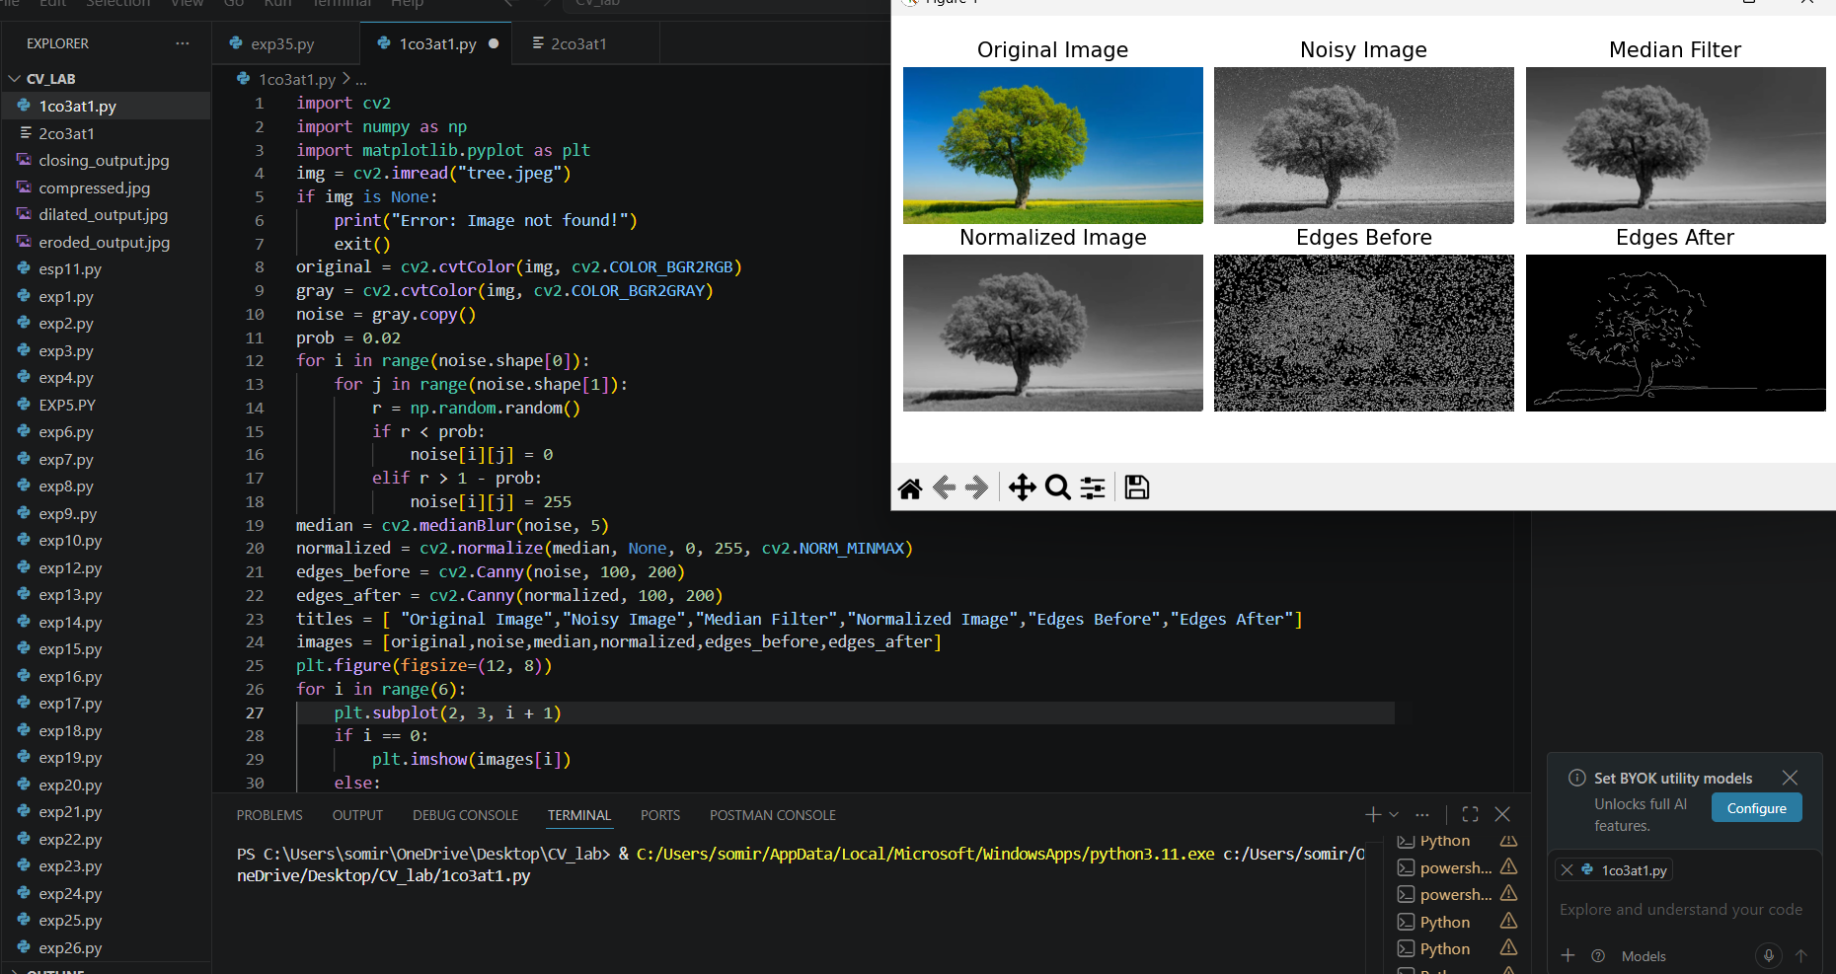
Result
The experiment successfully demonstrated that Median Filtering removes noise while preserving edges, and Normalization improves image contrast. As a result, Canny Edge Detection produced clearer and more accurate edges after preprocessing, proving that preprocessing significantly improves image quality and feature detection accuracy.

2. Image Representation Study
Conduct an experiment to convert a given image into grayscale and binary representations. Explain the significance of different image representations in computer vision applications. Design the conversion procedure using appropriate tools, document the generated outputs clearly, and analyze how image representation affects edge detection and feature extraction performance.
Ans:
Aim
To convert a given image into grayscale and binary representations and analyze their impact on edge detection and feature extraction using OpenCV.
Theory
Image representation is the process of expressing an image in different formats for analysis and processing. Different representations simplify image processing tasks and improve computational efficiency.
Grayscale Image
- Contains intensity values ranging from 0 to 255.
- Reduces image complexity by removing color information.
- Commonly used in image processing and computer vision.
Binary Image
- Contains only two pixel values (0 and 255).
- Generated using thresholding.
- Useful for object segmentation, shape analysis, and pattern recognition.
Edge Detection
Edge detection identifies object boundaries by detecting sudden changes in pixel intensity. Different image representations influence the quality of detected edges and extracted features.

Software Used
- Python 3.x
- OpenCV
- NumPy
- Matplotlib
Algorithm
- Read the input image.
- Convert the image into grayscale.
- Apply binary thresholding to create a binary image.
- Perform Canny edge detection on the grayscale image.
- Perform Canny edge detection on the binary image.
- Display all output images.
- Compare the edge detection results.
- Stop.
Python Code
import cv2
import matplotlib.pyplot as plt
img = cv2.imread("tree.jpeg")
gray = cv2.cvtColor(img, cv2.COLOR_BGR2GRAY)_, binary = cv2.threshold(gray, 127, 255, cv2.THRESH_BINARY)
edges_gray = cv2.Canny(gray, 100, 200)
edges_binary = cv2.Canny(binary, 100, 200)
titles = ['Original Image', 'Grayscale Image','Binary Image', 'Edges (Grayscale)',
'Edges (Binary)']
images = [cv2.cvtColor(img, cv2.COLOR_BGR2RGB), gray, binary, edges_gray, edges_binary]
plt.figure(figsize=(12,8))
for i in range(5):
plt.subplot(2,3,i+1)
if i == 0:
plt.imshow(images[i])
else:
plt.imshow(images[i], cmap='gray')
plt.title(titles[i])
plt.axis('off')
plt.tight_layout()
plt.show()
Output
Paste the screenshot of the program output here.
The output displays:
- Original Image
- Grayscale Image
- Binary Image
- Edge Detection on Grayscale Image
- Edge Detection on Binary Image

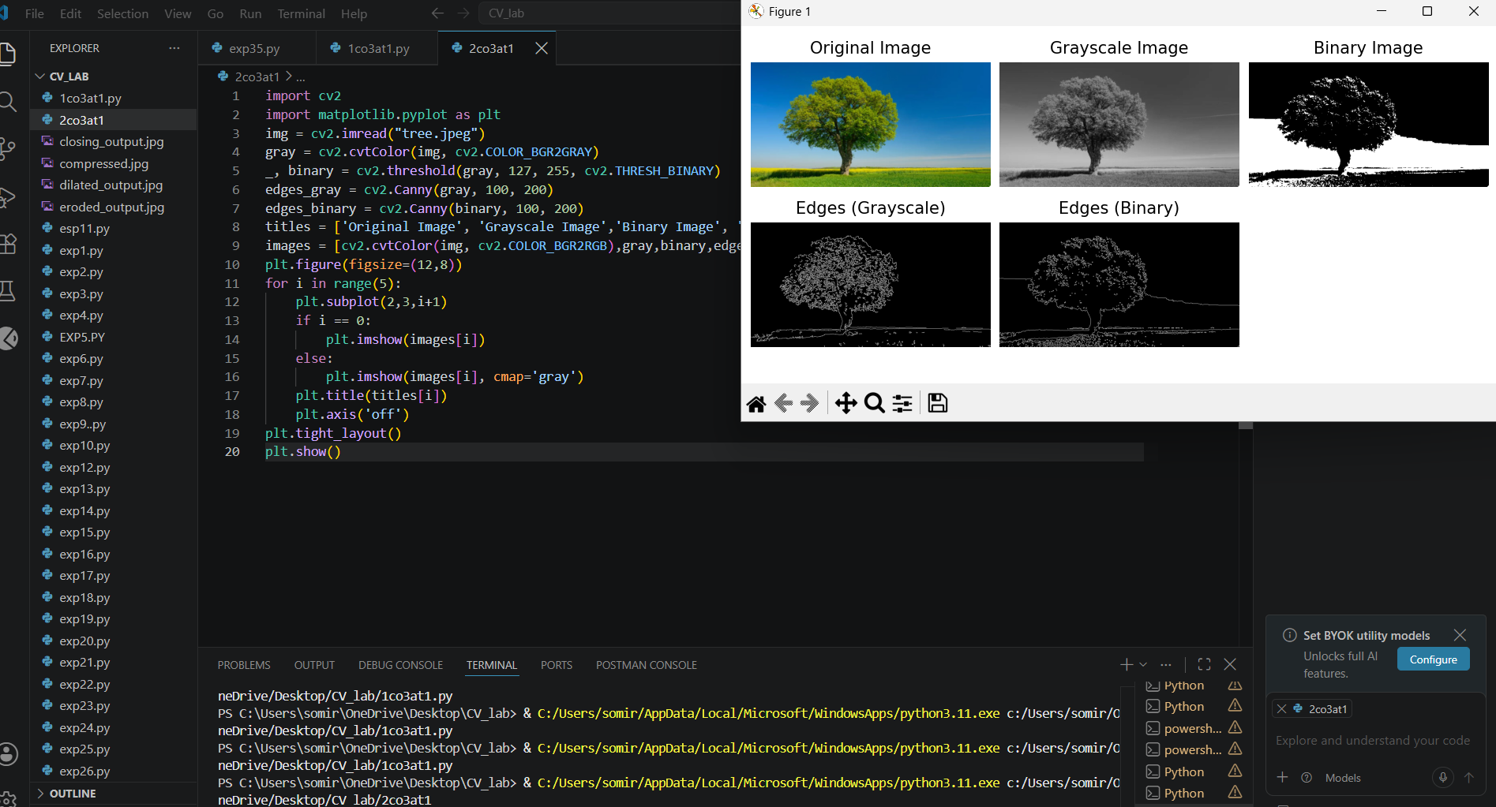

Result
The experiment successfully converted the input image into grayscale and binary representations. The grayscale image preserved more intensity information, resulting in better edge detection and feature extraction. The binary image simplified the image by separating the foreground from the background, making it suitable for segmentation and object recognition tasks. Thus, different image representations significantly affect the performance of edge detection and feature extraction in computer vision applications.

3. Edge Detection Comparison
Design an experiment to compare Sobel and Canny edge detection techniques on the same input image. Explain the underlying concepts and operational principles of both methods. Apply the techniques using suitable tools/software, document the detected edges systematically, and analyze the comparative effectiveness of each method for different image conditions and applications.
Ans:
Edge Detection Comparison
Aim
To compare Sobel and Canny edge detection techniques on the same input image and analyze their effectiveness under different image conditions.
Theory
Sobel Edge Detection calculates the intensity gradient in horizontal and vertical directions to identify edges. It is simple and useful for detecting basic edges.
Canny Edge Detection is a multi-stage method that includes noise reduction, gradient calculation, non-maximum suppression, double thresholding, and edge tracking. It generally produces thinner and cleaner edges.
Comparison
Feature | Sobel | Canny
Method | Gradient-based | Multi-stage
Noise Handling | Moderate | Better
Edge Thickness | Thicker | Thin
Accuracy | Moderate | High
Processing | Faster | More computational

Software Used
- Python 3.x
- OpenCV
- NumPy
- Matplotlib
Algorithm
- Read the input image.
- Convert the image to grayscale.
- Apply Sobel filtering in the X and Y directions.
- Combine the Sobel gradients to obtain the edge image.
- Apply the Canny Edge Detection algorithm.
- Display the original, Sobel, and Canny results.
- Compare the detected edges.
- Stop.

Python Code
import cv2
import numpy as np
import matplotlib.pyplot as plt
img = cv2.imread("treee.jpeg")
if img is None:
print("Error: Image not found!")
exit()
gray = cv2.cvtColor(img, cv2.COLOR_BGR2GRAY)
sobel_x = cv2.Sobel(gray, cv2.CV_64F, 1, 0, ksize=3)
sobel_y = cv2.Sobel(gray, cv2.CV_64F, 0, 1, ksize=3)
sobel = cv2.magnitude( np.float32(sobel_x), np.float32(sobel_y))
sobel = cv2.convertScaleAbs(sobel)
canny = cv2.Canny(gray, 100, 200)
original = cv2.cvtColor(img, cv2.COLOR_BGR2RGB)
titles = [ "Original Image","Sobel Edge Detection", "Canny Edge Detection"]
images = [ original,sobel,canny]
plt.figure(figsize=(12, 5))
for i in range(3):
plt.subplot(1, 3, i + 1)
if i == 0:
plt.imshow(images[i])
else:
plt.imshow(images[i], cmap="gray")
plt.title(titles[i])
plt.axis("off")
plt.tight_layout()
plt.show()
Output
The output displays:
- Original Color Image
- Sobel Edge Detection
- Canny Edge Detection
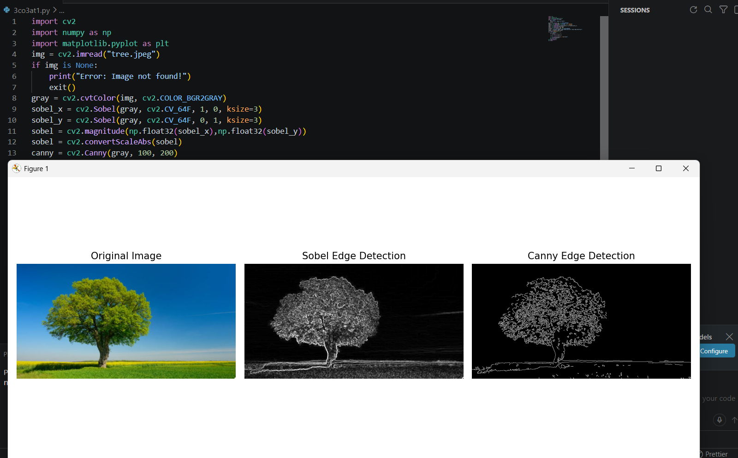
Result
The experiment successfully compared Sobel and Canny edge detection techniques. Sobel detects edges quickly but may produce thicker and noisy edges. Canny provides clearer, thinner, and more accurate edges due to its multi-stage process. Therefore, Sobel is suitable for simple and fast edge detection, while Canny is more effective for applications requiring accurate object boundaries, such as object detection and image segmentation.

